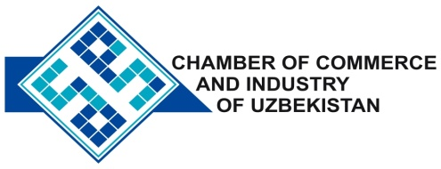

**Commercial offer of Uzbek Products to Foreign Buyer**

Dear Sirs, №SHP-017

We offer quotation of Uzbek companies SP «ALFI TEKSTIL» LLC.

**Information about the company:**

«ALFI TEKSTIL» The Company was founded in 2006. The company specializes in the production of male and female knitted garments of the highest quality.

**List of products:**

Mikey

Underpants

T-shirts

Night shirts

Bathrobes

Shirts "Polo"

Towel

**Benefits:**

100% Cotton, top quality.

**Terms of delivery:** FCA Tashkent

If you are interested, we are happy to provide additional information in accordance with your request.

E-mail: [export@chamber.uz](mailto:export@chamber.uz)

Website: [www.chamber.uz](http://www.chamber.uz)

Export Promotion Department.

Chamber of Commerce of the Republic of Uzbekistan.